Project Planning Phase
Project Planning Template (Product Backlog, Sprint Planning, Stories, Story points)

Date | 05 February 2026
Team ID | LTVIP2026TMIDS55759
Project Name | Strategic Product Placement Analysis: Unveiling Sales Impact with Tableau Visualization
Maximum Marks | 5 Marks

Product Backlog, Sprint Schedule, and Estimation (4 Marks)
Use the below template to create product backlog and sprint schedule

Sprint | Functional  Requirement (Epic) | User Story  Number | User Story / Task | Story Points | Priority | Team  Members
Sprint-1 | Data collect and Extraction of data | USN-1 | Collection of data | 3 | High | VedaPriya
Sprint-1 |  | USN-2 | Understanding data | 2 | medium | Kanth
Sprint-1 |  | USN-3 | Connecting the data set with tableau | 2 | medium | Pavan
Sprint-2 | Data preparation | USN-1 | Prepare the data for visulization | 3 | High | Pavan
Sprint-3 | Data visulization | USN-1 | No.of unique vizulation | 3 | High | Vedapriya
Sprint-3 | Dashboard | USN-1 | Create of dashboard | 3 | High | Kanth
Sprint-4 | stroy | USN-1 | Create story | 2 | medium | Gopi
Sprint | Performance testing | USN-1 | testing | 2 | medium | Gopi

Project Tracker, Velocity & Burndown Chart: (4 Marks)

Sprint | Total Story Points | Duration | Sprint Start Date | Sprint End Date (Planned) | Story Points  Completed (as on Planned End Date) | Sprint Release Date (Actual)
Sprint-1 | 7 | 6 Days | 29 January 2026 | 03 February 2026 | 7 | 29 January 2026
Sprint-2 | 2 | 6 Days | 03 February 2026 | 09 February 2026 | 3 | 09 February 2026
Sprint-3 | 6 | 6 Days | 09 February 2026 | 14 February 2026 | 6 | 14 February 2026
Sprint-4 | 4 | 6 Days | 14 February 2026 | 20 February 2026 | 4 | 20 February 2026

Velocity:
Total Story Points
Sprint 1 = 7
Sprint 2 = 3
Sprint 3 = 6
Sprint 4 = 4

Velocity= Total Story Points Completed/ Number of Sprints Total story Points= 7+3=6+4 =20
No of Sprints= 4
Velocity = (16+8)/2= 20/4 5 (Story Points per Sprint)
Your team’s velocity is 5 Story Points per Sprint.

Time line:
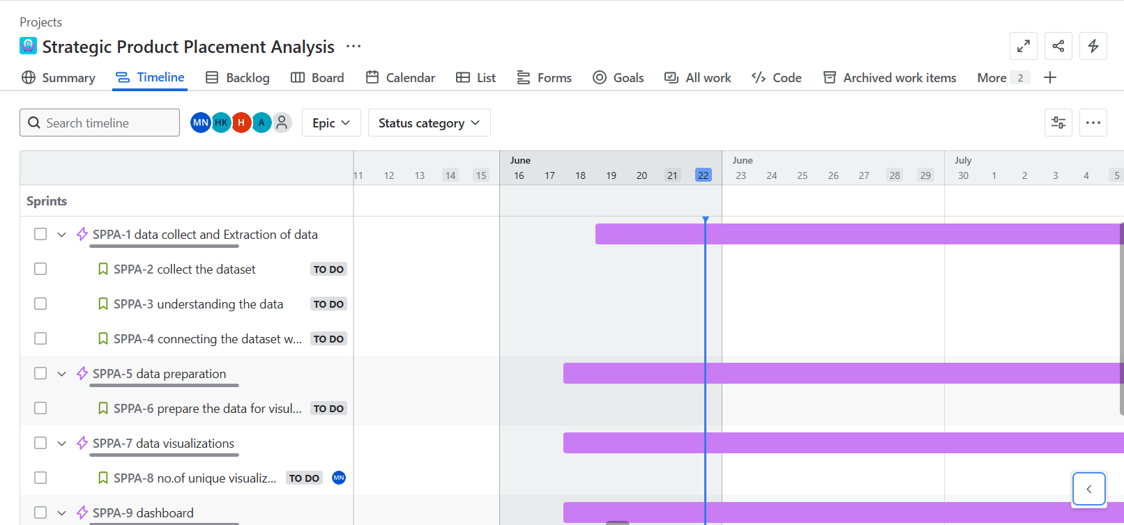

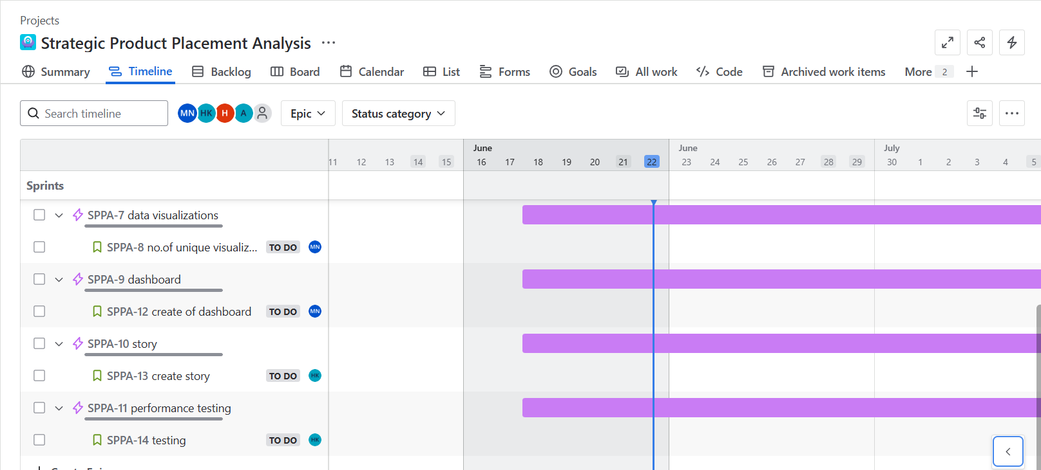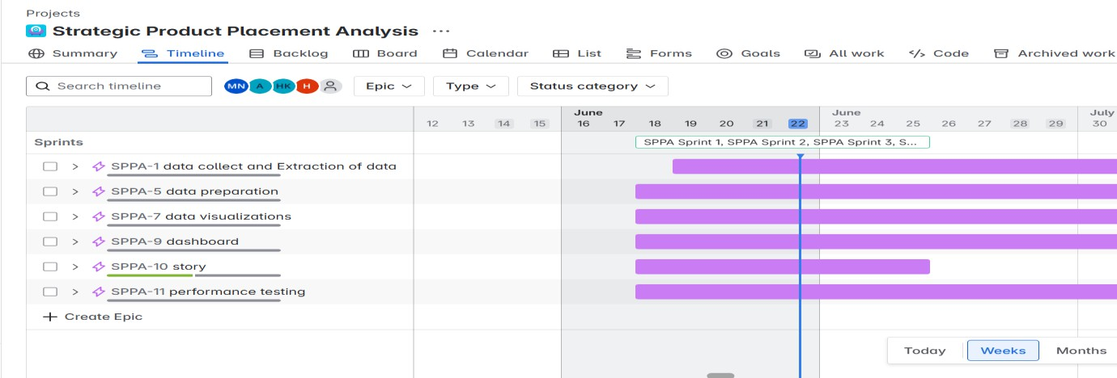

Backlog:

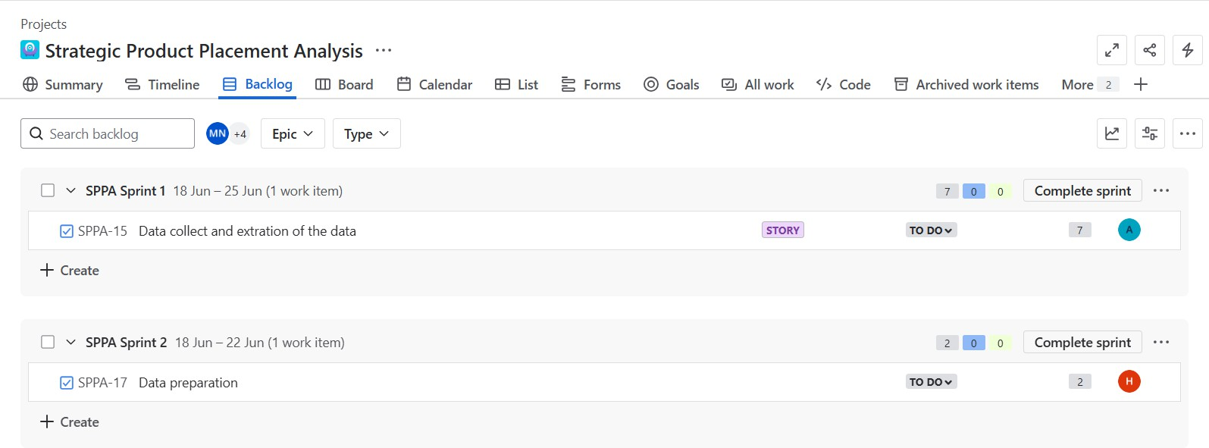
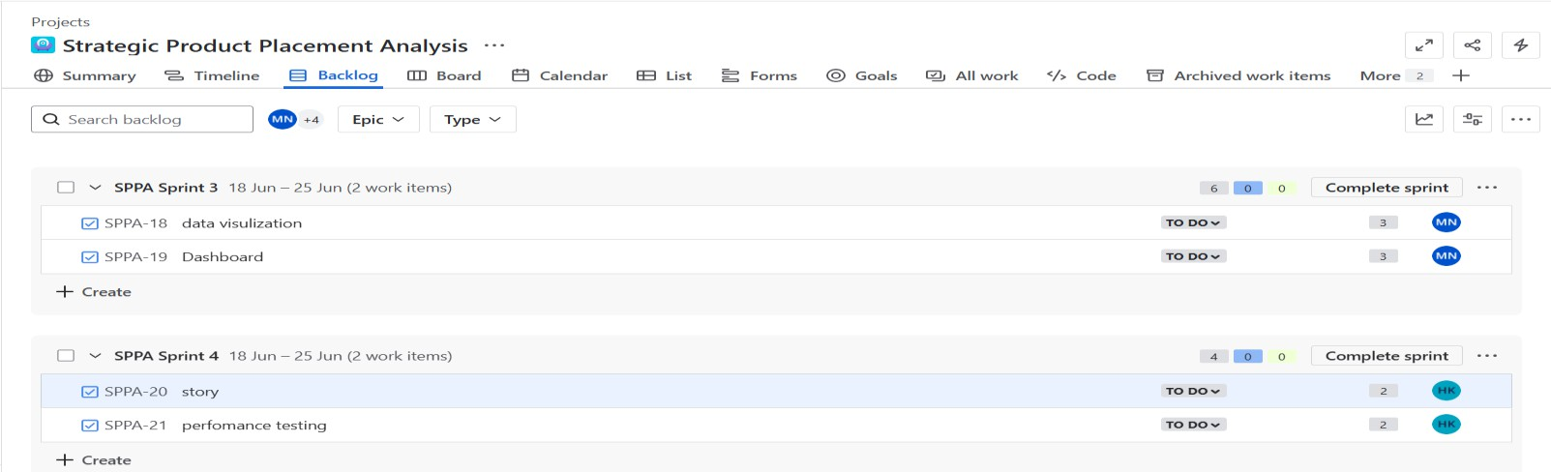

Board:
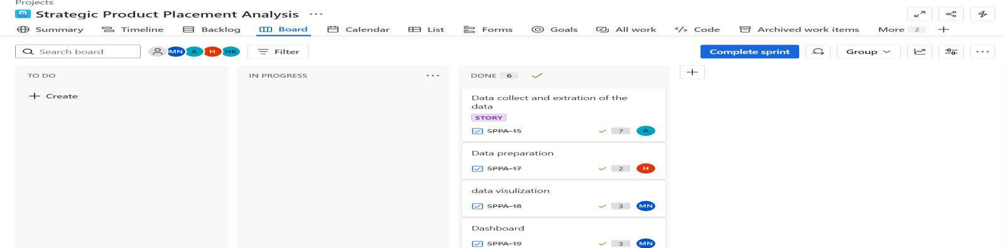

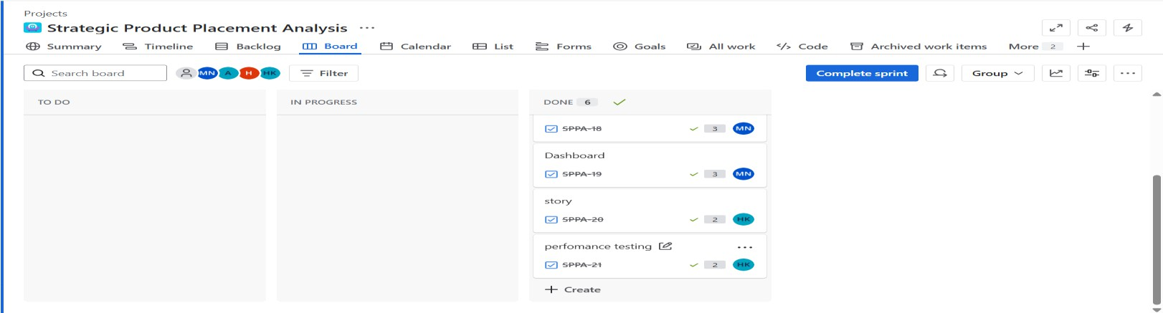

Burndown Chart:
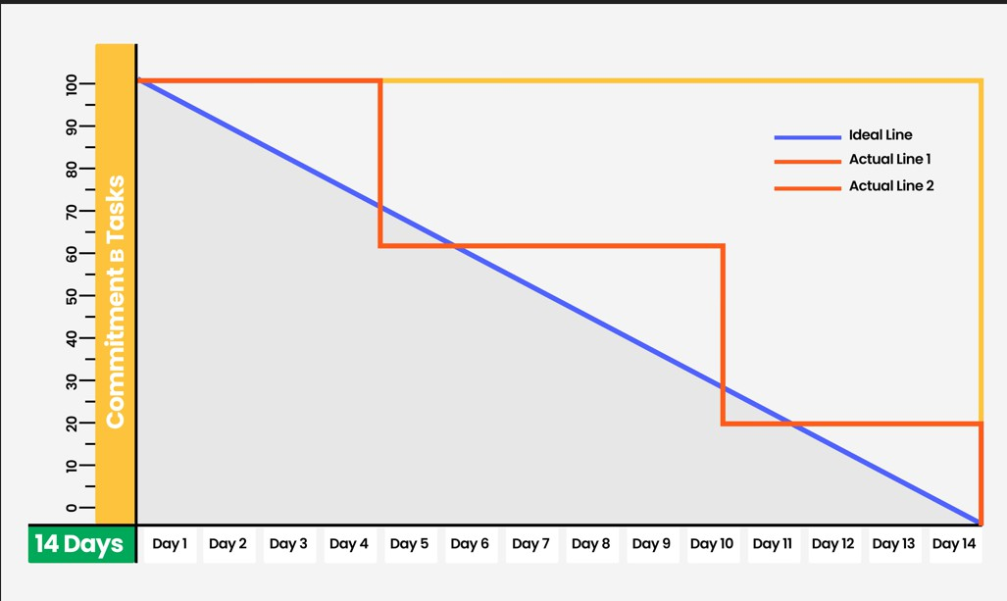

A burn down chart is a graphical representation of work left to do versus time. It is often used in agile software
development methodologies such as Scrum. However, burn down charts can be applied to any project containing measurable progress over time.

https://www.visual-paradigm.com/scrum/scrum-burndown-chart/ https://www.atlassian.com/agile/tutorials/burndown-charts

Reference:
https://www.atlassian.com/agile/project-management https://www.atlassian.com/agile/tutorials/how-to-do-scrum-with-jira-software https://www.atlassian.com/agile/tutorials/epics https://www.atlassian.com/agile/tutorials/sprints https://www.atlassian.com/agile/project-management/estimation https://www.atlassian.com/agile/tutorials/burndown-charts

